Research-based Argument Essay Prompt

(adapted from Ali Shapiro and Tricia Khleif’s assignments in the English Department Writing Program Guide)

Essay Final Draft Due Date: Tuesday, November 19 by 11:59 pm

Length and Formatting Guidelines: The essay should be 8-10 pages long, double-spaced, using 12-point font.

- Include a header (with your name, the date, and the course name/number).
- Include a creative and specific title.
- Include a works cited page using MLA citation style (with at least three secondary sources).

Submission Guidelines: Submit the drafts and materials on Canvas under Assignments by the beginning of class on each specified date.

Purpose: The purpose of the research-based argument essay is to “develop a thesis-driven argument that draws on original research to contribute to an academic conversation or scholarly debate.” In this assignment, you will investigate a cultural or social phenomenon using research methods including library research and fieldwork (observation, survey, interview, or experiment). This is your opportunity to examine, research, and contribute an original idea on an issue or topic that holds interest or importance to you.

Research Methods:

- Library Research (Secondary Sources):

Include and cite at least three credible secondary sources (articles, books, etc.).

Be sure to contribute an original idea to the conversation (Gaipa): add your own voice and argument to debates on the topics, and challenge or expand upon the sources rather than simply agreeing with or summarizing others’ ideas.

- Fieldwork (Primary Sources):

Conduct at least one of the following, then collect and analyze the data:

  - Experiment: actively participate in and test out the phenomenon.
  - Observation: observe the phenomenon in action.
  - Interview: ask questions of one or more people.
  - Survey: ask questions of a large number of people.

Sample Topics:

(from Ali Shapiro’s assignment in the English Department Writing Program Guide)

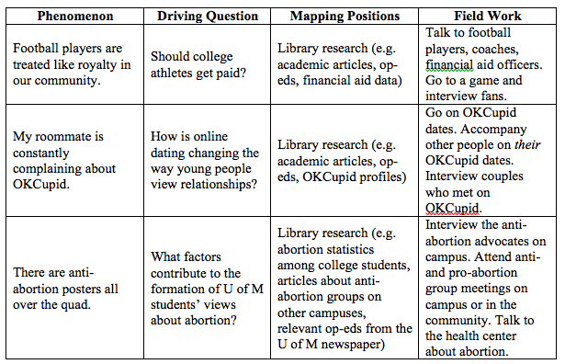

Prewriting 1: Project Proposal (LSA 7): due on Thursday, October 31 (1-2 pages, double-spaced)

- Driving Question (at least one paragraph):

- Include and explain your research question with specificity and detail.
- Articulate the significance of the topic to you and to an outside reader.

- Fieldwork Plan (at least one paragraph):

- Describe your fieldwork plan in detail. Choose at least one of the following: experiment, observation, interview, or survey.
  - Include the names of the people you plan to interview or survey, or the events or spaces you plan to attend or observe.
  - For interviews/surveys/observations, include at least five questions; for experiments, include at least five hypotheses.
  - Estimate the timeline for completion (schedule fieldwork tasks before Wednesday, March 21).

- Perspective/Positionality (a brief one-two sentence explanation):

- Include a note in which you position yourself in relation to the topic:
  - Are you an insider or outsider in relation to this discourse community?
  - Do you have any biases, or hypotheses or expectations that you have already formed about this topic?

Prewriting 2: Data Collection Field Notes (LSA 8): due on Thursday, November 7 (1-2 pages, double-spaced)

The format and content of your field notes may vary based on your chosen method; these are recommended guidelines:

- Experiment: describe the experiment you conducted and reflect upon the findings (include 5 hypotheses).
- Observation: describe the observation you conducted and reflect upon the findings (include 5 questions).
- Interview: include the interview transcription (include 5 questions).
- Survey: include the survey data and results; create tables/charts/graphs that illustrate the data (optional) (include 5 questions).

Steps toward Research:

- Attend a library research session.
- Practice creating and conducting interviews and surveys in class on Thursday, October 31.

Essay Structure:

Exposition:

- Introduce and establish the topic, background, and setting; share the reasons behind your interest in the topic (the introduction can include narrative elements such as description and scene-setting).
- Situate the topic within the larger context and conversation.

Positionality:

- Include a note in which you position yourself in relation to the topic:
- Are you an insider or outsider in relation to this discourse community?
- Do you have any biases, or hypotheses or expectations that you have already formed about this topic?

Driving Questions:

- Finally, include a clear, specific research question(s). Articulate the significance of the questions to you and to an outside reader.

Secondary Sources:

- Cite and introduce secondary sources related to your topic.
- Explain how your essay challenges, expands upon, or differs from previous studies; and state how you plan to contribute a new idea or perspective on the issue.

Primary Fieldwork Research and Data:

- Describe the fieldwork you conducted (experiment, observation, interview, or survey).
- Include the data and results; optionally, create tables/charts/graphs that illustrate the data.

Analysis and Discussion:

- Interpret the significance of the findings: Are the results what you expected? Why or why not? Has your research changed your perspective or offered you new insights on the issue? If so, how?

Conclusion:

- Reflect upon the larger implications of your study and situate the project within a broader conversation.
- Indicate related or unanswered questions or suggest future directions for research on this topic.

Materials for Study:

Published Essays:
- Excerpts from Nicholas Carr, The Shallows
- Bill Cope and Mary Kalantzis, “Multiliteracies: New Literacies, New Learning”

Sample Essay:
- “A Tale of Two Ice Cream Stores”

Criteria:

Note: The difference between and A- and B-level paper is that while an A-level paper offers a sophisticated, original, and innovative idea, a B-level paper offers observations that are less original and well-crafted. A C-level paper may offer summary instead of analysis and provide less thorough development and support.

Development/Argument: | Structure/Organization: | Craft/Language:
A-Level: Extraordinary
- Development: thoroughly develops ideas using specific evidence and consistent attention to detail  - Driving Question: includes a specific, complex, and nuanced research question(s)  - Originality: contributes a new idea or perspective on the issue and explains how the argument differs from those of previous studies  - Analysis: offers an insightful and sophisticated analysis of the data and findings | - Organization: incorporates a clear structure (introduction, body paragraphs, and conclusion)  - Transitions: integrates varied transition words and phrases in order to create a clear logical flow | - Word Choice: employs precise, subject-specific vocabulary and an authentic voice  - Grammar and Style: is written consistently in the present tense, using appropriate grammar and style
B-Level: Excellent
- Development: develops ideas using specific evidence, though some examples may be less thoroughly supported  - Driving Question: includes a clear, though less specific, complex, or nuanced research question(s)  - Originality: explains insights that may be similar to those found in previous studies  - Analysis: offers an effective, though less sophisticated, analysis of the data and findings | - Organization: incorporates a generally clear structure (introduction, body paragraphs, and conclusion)  - Transitions: integrates varied transition words and phrases | - Vocabulary: employs generally effective word choice and voice  - Grammar: is written consistently in the present tense using appropriate grammar and style, though there may be a few errors

Research-based Essay Assignment Schedule

Formatting: Each assignment should be typed, double-spaced, using 12 pt. font.

Assignment | Due Date | Submission Guidelines
Project proposal (LSWA 7) | Thursday, October 31 by 8:30 am | Upload onto Canvas under Assignments.
Data collection field notes (LSWA 8) | Thursday, November 7 by 8:30 am | Upload onto Canvas under Assignments.
Essay first draft (8-10 pages) | Thursday, November 7 by 10 am (by the end of class) | Email the essay to each group member and me.
Peer review workshop/peer review letters | Tuesday, November 12 by 8:30 am | - Email the letters to each group member and me.  - Bring hard copies of the letters for each group member and yourself.
Essay final draft + materials (8-10 pages) | Tuesday, November 19 by 11:59 pm | Include in one Word document:  - Final draft  - First draft  - Letters from peer reviewers  - Reflective cover letter or annotations

Note: The guidelines and criteria for cover letters/annotations and low-stakes writing assignments are the same as in the first two units.

